Computer Science II – Prepa Tec Campus Eugenio Garza Lagüera

Activity 1: Review

*“En esta actividad me comprometo a aplicar mis conocimientos, esforzarme en su desarrollo y no servirme de medios no autorizados o ilícitos para realizarla. Es de mi conocimiento, que debo entregar a través de la plataforma Canvas los procesos realizados ya que ningún resultado tiene valor sin proceso.”*

Name: ________________________________________ Student Id: ___________ Signature: __________

**Turn in the answers to the following exercises by hand.**

**Problem 1**

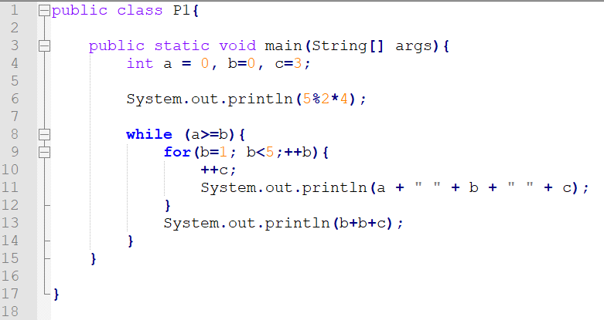

Complete a code trace of the code above.

|  |  |  |  |
| --- | --- | --- | --- |
| **a** | **b** | **c** | **Output** |
|  |  |  |  |
|  |  |  |  |
|  |  |  |  |
|  |  |  |  |
|  |  |  |  |
|  |  |  |  |
|  |  |  |  |

1. What is the difference in output between lines 11 and 13?
2. How many times is the **for** loop executed? Why?
3. How many times is the **while** loop executed? Why?
4. What does line 10 do?
5. What is the control variable for each loop in the program?

**Problem #2**

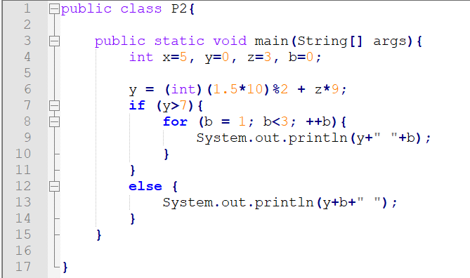

Complete a code trace of the code above.

|  |  |  |  |  |
| --- | --- | --- | --- | --- |
| **b** | **x** | **y** | **z** | **Output** |
|  |  |  |  |  |
|  |  |  |  |  |
|  |  |  |  |  |
|  |  |  |  |  |
|  |  |  |  |  |
|  |  |  |  |  |
|  |  |  |  |  |

1. Are there any errors in the code above?
2. What is the final value of variable y?
3. What is the difference between the output generated by lines 9 and 13?
4. How many times is the **for** loop executed?
5. Where is the **casting** being done in the code above? What is the purpose of it?

Problem #3

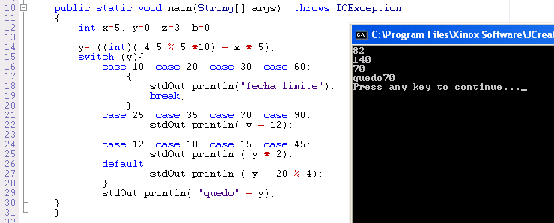

1. What does line 16 do?
2. Which braces { } can be considered optional in the code above? Why?
3. Are there any errors in the code above? Are they logic, syntax or runtime errors?
4. What do you have to keep in mind when using a **switch** statement?
5. List two advantages of using a **switch** offer an **if** in the code above.

**Problem 4:**

Imagine you have a car dealership that sells two types of cars: a basic model and an equipped model. Customers can buy these cars either by paying in cash or by financing them.

If someone pays in cash, they receive a 10% discount on the basic car and a 15% discount on the equipped one. However, if they choose to finance the car, the price increases by 25%, spread out over 48 monthly installments.

Create a Java class that calculates the total payment a customer needs to make based on their chosen car type and payment method. If they opt for financing, the program should also show the monthly payment.